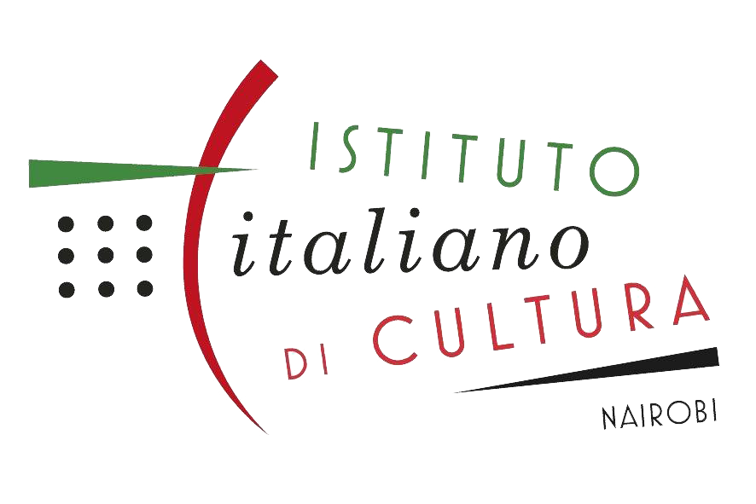
ISTITUTO ITALIANO DI CULTURA – NAIROBI

ENROLMENT FORM

Complete and return this form to IIC, together with bank deposit/transfer slip & copy of ID
nairobi.iicitaliano@esteri.it

Bank details:

NCBA Village Market branch

Acc.: Embassy of Italy – iic

Acc n.: 6708230017

Name & Surname

Nationality Profession

Prior knowledge of Italian language

Aim of leaning Italian

Educational background

P.O. Box n. Postal Code

Tel. (Off.) Mobile

E-mail address

Indicate the course you have chosen: in presence online
- A1 a - Beginner - A1 b - Beginner
- A2 a - Beginner level 2 - A2 b - Beginner level 2
- B1 a - Intermediate - B1 b - Intermediate

- - - - - - - - - - - - - - - - - - - - - - - - - - - - - - - - - - - - - - - - - - - - - - - - - - - - - - - - - - - - - - - - - - - - - -
IIC OFFICIAL USE

Enrolled to Teacher

Payment Receipt

